TU 257 – Fundamentals of Data Science

Data Analytics

L3 – Data Exploration & Preparation

Brendan Tierney

•

Slightly ahead

•

Slightly behind

•

Second chance to understand

•

In more detail

•

R

einforcement

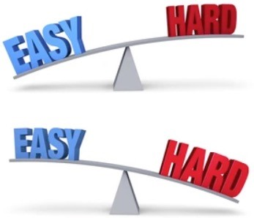

* Sampling & Subsetting the Dataset

Agenda

•

Why do we explore the data

•

Understanding your Data (Good, Bad & Ugly)

•

Low hanging fruits

•

Preparing Data

–

You have many tools in the toolbox

•

Missing Values

•

Recoding Values

•

Correlated Data

•

Feature Engineering

•

Imbalanced Data Sets

No Magic Solution



* Splitting Data

|  |
| --- |
| * Iterative in Nature * You won’t get it right first time * Experiment to see what works |

A set of tools

Every Data Set is different

# Data Wrangling module vs This Module

* Pandas
* Indexing
* Reading files JSON, XML, web scraping etc
* Writing files
* Data Quality
* Data Profiling
* Visualisation
* Data Cleaning
* Data Subsetting
* Data Preparation, Normalisation ,etc
* Getting Data
* Replacing Missing values (Imputing Values)
* Can also remove data
* Recoding Data (Transforming)
* Categorical
* Numerical
* Subsetting
* Correlated Data
* Feature Engineering
* Handing Imbalanced data set
* Sampling Data
* Splitting Data into different data sets

# Data Wrangling module vs This Module

•

Pandas

•

Indexing

•

Reading files JSON, XML, web scraping etc

•

Writing files

•

Data Quality

•

Data Profiling

•

Visualisation

•

Data Cleaning

•

Data

Subsetting

•

Data Preparation, Normalisation ,etc

•

Getting Data

•

Replacing Missing values (Imputing Values)

•

Can also remove data

•

Recoding Data (Transforming)

•

Categorical

•

Numerical

•

Subsetting

•

Correlated Data

•

Feature Engineering

•

Handing Imbalanced data set

•

Sampling Data

•

Splitting Data into different data sets

Get Data

Missing Data

Recoding Data

Standardising Data Values

Create new Features

Splitting Features

Calculations based on other Features

Categorical

Numerical

Merge /

Integrate Data

Feature

Reduction

Stats

Charts/Visualisations

Problem Definition

Data Cleaning

Data

Transformations

Data

Engineering

Explore &

Understand

Sampling

Data

Splitting

Data

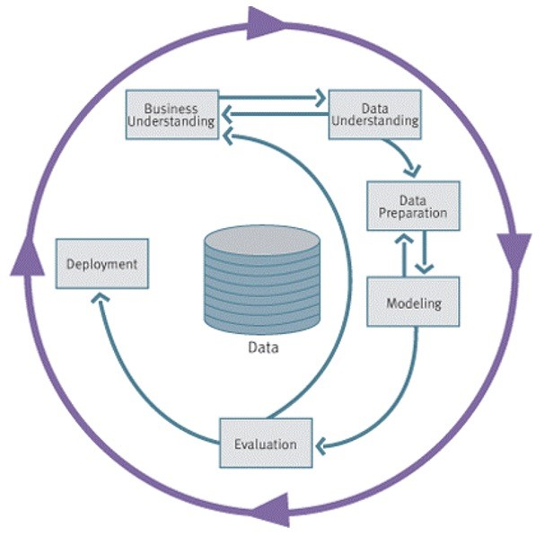

7



Phase 2

–

Data Understanding

•

Acquire the data

•

Explore the data (query & visualization)

•

Verify the quality

•

Starts with an initial data collection and proceeds with

activities in order to get familiar with the data, to identify

data quality problems, to discover first insights into the data

or to detect interesting subsets to form hypotheses for

hidden information.

8

Business

Understanding

Data

Understanding

Data

Preparation

Modeling

Deployment

Evaluation

Collect

Initial

Data

Describe

Data

Explore

Data

Data

Quality Plan



Phase 3

–

Data Preparation

Data preparation:

•

Collection

•

Assessment

•

Consolidation and Cleaning

•

table links, aggregation level, missing values,

etc

•

Data selection

•

active role in ignoring non

-

contributory data?

•

outliers?

•

Use of samples

•

visualization tools

•

Transformations

-

create new variables

•

Covers all activities to construct the final dataset from the initial raw data.

Data preparation tasks are likely to be performed multiple times and not in any

prescribed order. Tasks include table, record and attribute selection as well as

transformation and cleaning of data for modeling tools.

9

Business

Understanding

Data

Understanding

Data

Preparation

Modeling

Deployment

Evaluation

Select

Data

Clean

Data

Construct

Data

Integrate

Data

Format

Data

Why do we explore the data ?

# Need to know and understand you Data

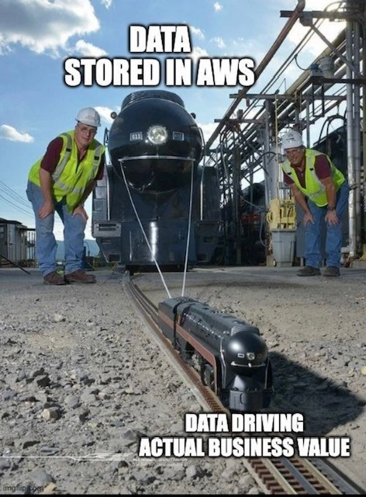

* What Data do you have? (easy access to)
* What Data would you like to have?
* Not always possible to have all the data you want !
* You will never need ALL the data – Big Data isn’t a problem
* What is Big Data Really!
* Get to know your data
* Data Audit
* Data Quality Report

Remember

* Automated Data Exploration?
* Using Different Pandas functions?
* What you have vs What you don’t have
* How clean is the data vs how dirty is it
* How consistent is the data vs how inconsistent it is
* Particularly when you merge data from different sources
* Is data available from one Data Source vs How many different Data Sources
* In most cases, Data will come from different Data Sources
* Different Data Sources => Differences in Data formats, values, representations • All of these need to be cleaned up, to make it consistent.
* You’d think data in your Enterprise is clean, consistent, good quality, etc
* It generally isn’t !

# Data Audit & Quality Report

* A data quality report includes tabular reports that describe the characteristics of each feature (column)
* The tabular reports are accompanied by data visualizations:
* A histogram for each continuous feature.

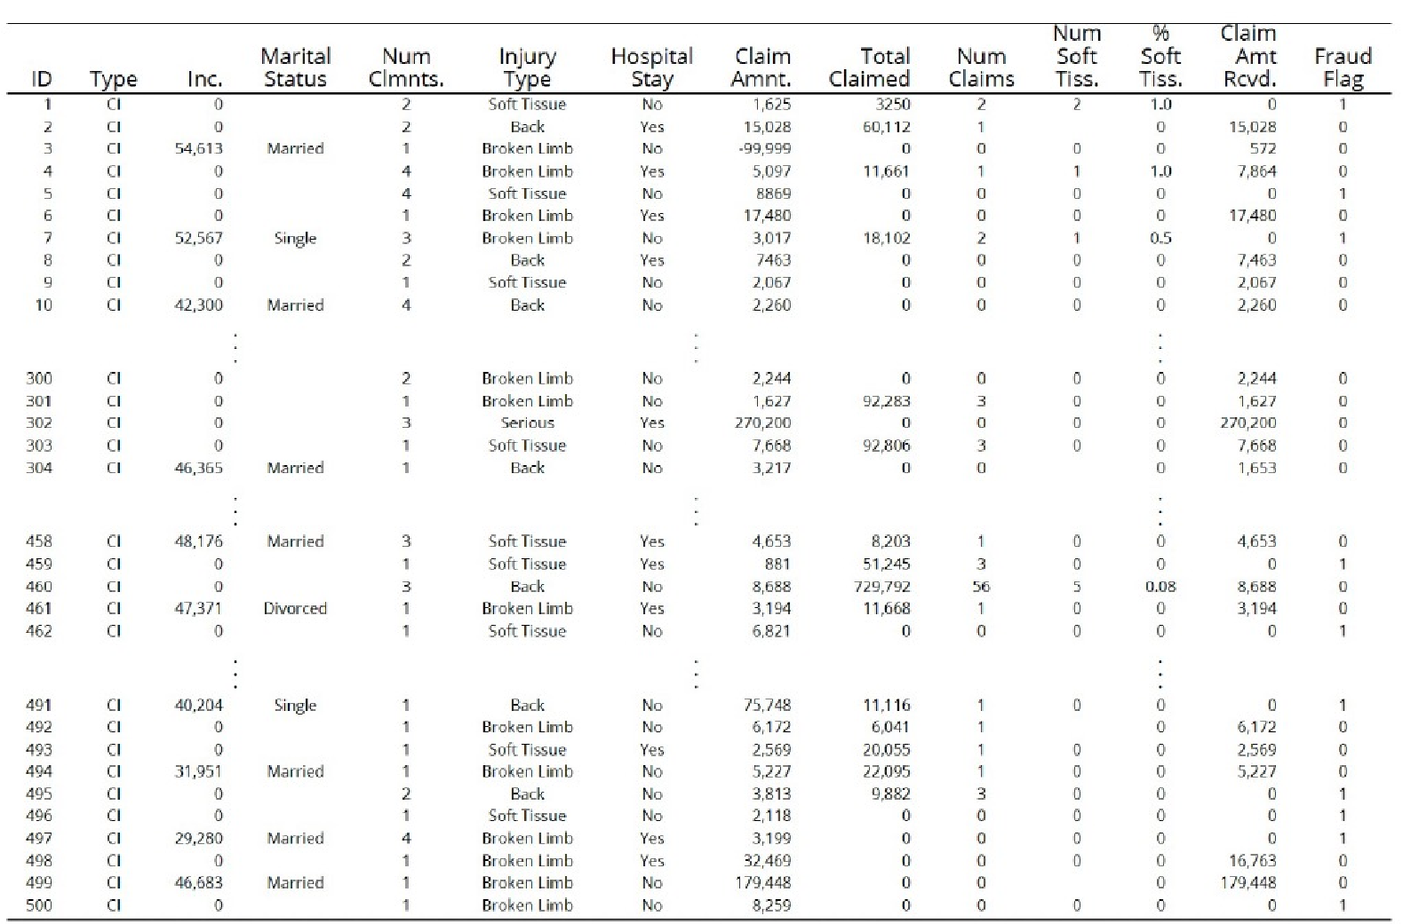

•

A bar plot for each categorical feature.

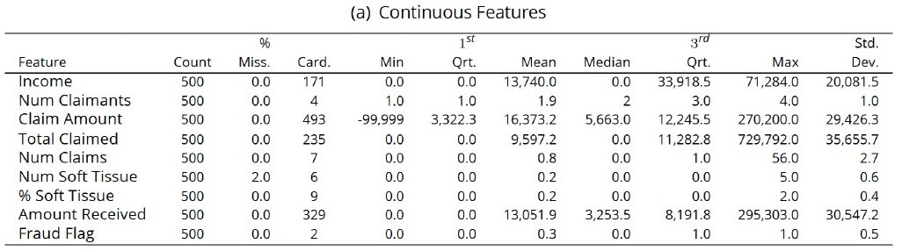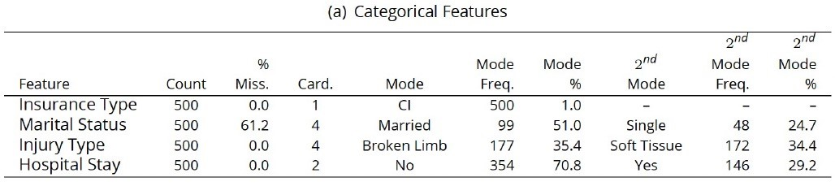

Plus charts/graphs of each feature

# Data Audit & Quality Report

* Have you seen something like this before?
* Automated Data Exploration – Remember example and exercises from last week
* Explore the Data
* What patterns do you see?
* Can you connect any Domain Knowledge to the patterns you are seeing?
* Nothing magical with doing this
* Nobody or thing will tell you the meaning of these patterns
* It is your job to make the connections
* Start Building a Picture of what is happening in the Data & what work needs to be done to the data
* Iterate to improve your understanding

Low hanging fruits

# Pick the Low Hanging Fruits

* All too often people look to use advanced and unnecessary algorithms, tools, approaches etc. Before doing the simple and basic things
* Most of the valuable Data Insights can be achieved by examining the data
* See what patterns you have
* Can you related to Domain Knowledge or Certain Events
* Discuss with Business Users
* Can be used to Verify existing Knowledge & Identify new Knowledge

|  |
| --- |
| * Can/Will be iterative * Can generate more questions from Business for you to explore in Data * Can identify more questions for Business to clarify and verify |

# Pick the Low Hanging Fruits

* Identify Patterns
* Can these be converted into Rules
* Can you prioritise these Rules
* Create IF…THEN
* Eg. Car Insurance industry – Claims
* Age profile
* Driving experience
* Type of Car
* Value of Car
* Job
* Service History
* Payment Schedule

By analysing this data you can identify certain patterns in the data?

Based on your Domain Knowledge, can you identify possible Rules/Patterns?

These would need to be verified with the Business.

* Data Sets available online vs Real World
* Most/All Data Sets online you get are Clean-ish
* Most of what we will cover in remaining slides are examples of things you need to look out for.
* Even if the Data Set seems clean, you still need to check and verify it.
* In Real World data sets, you can spend a lot of time merging and cleaning the data (and using what is covered in remaining slides)
* 80+% of project time
* Know your Tool/Product
* Most Enterprise BI/DM/ML/AI solutions – Do these tasks/steps automatically
* Automate the boring stuff
* Most FREE products don’t - R, Python, Julia,

Spark, etc

* Needs to be manually coded! Boring!

Wastes a lot of time! Expensive for

Businesses

* Mistakes can happen

# Preparing Data – You have many tools in the toolbox

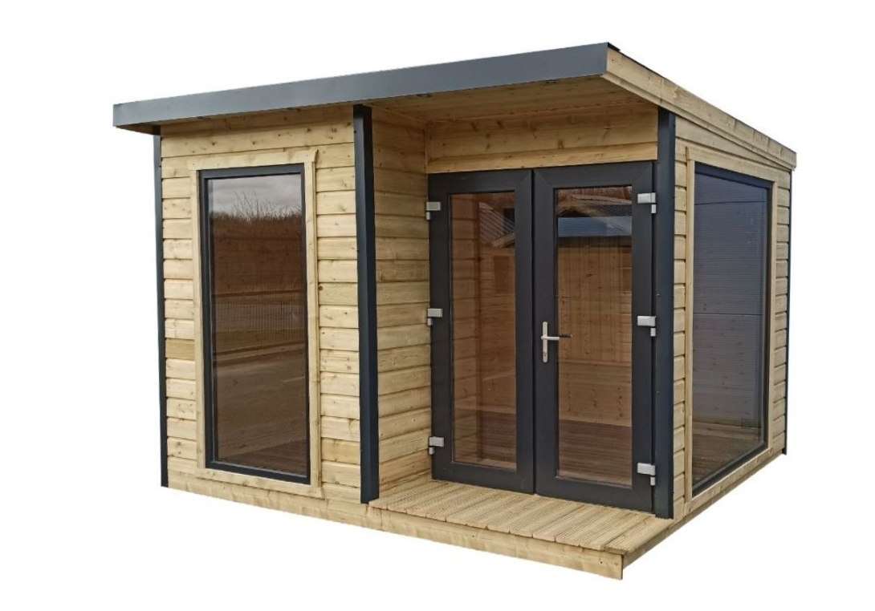

Your Toolbox



Your Toolbox



From Basics

to Experienced

Takes Time

& Practice

Explore your Data

# Last Week Lab Exercise

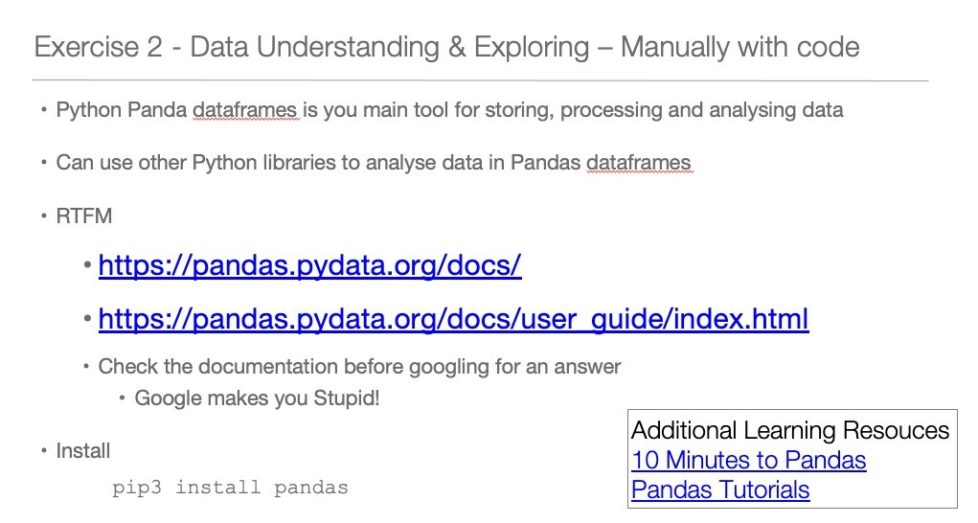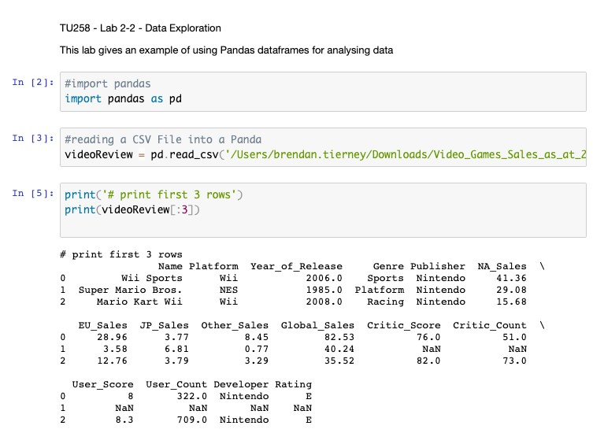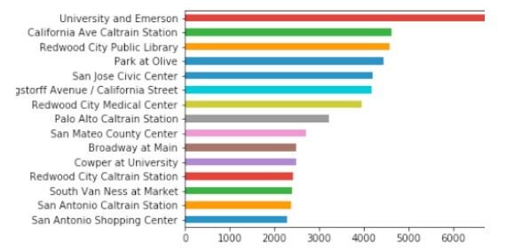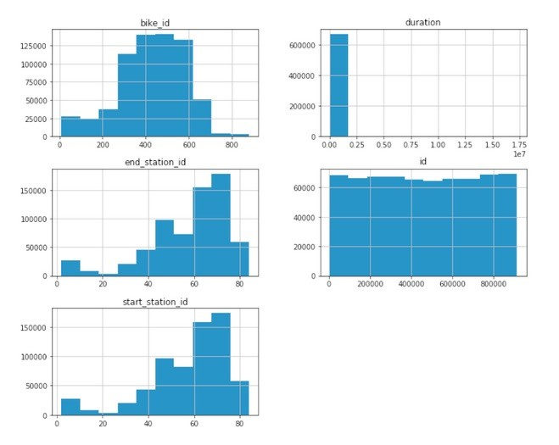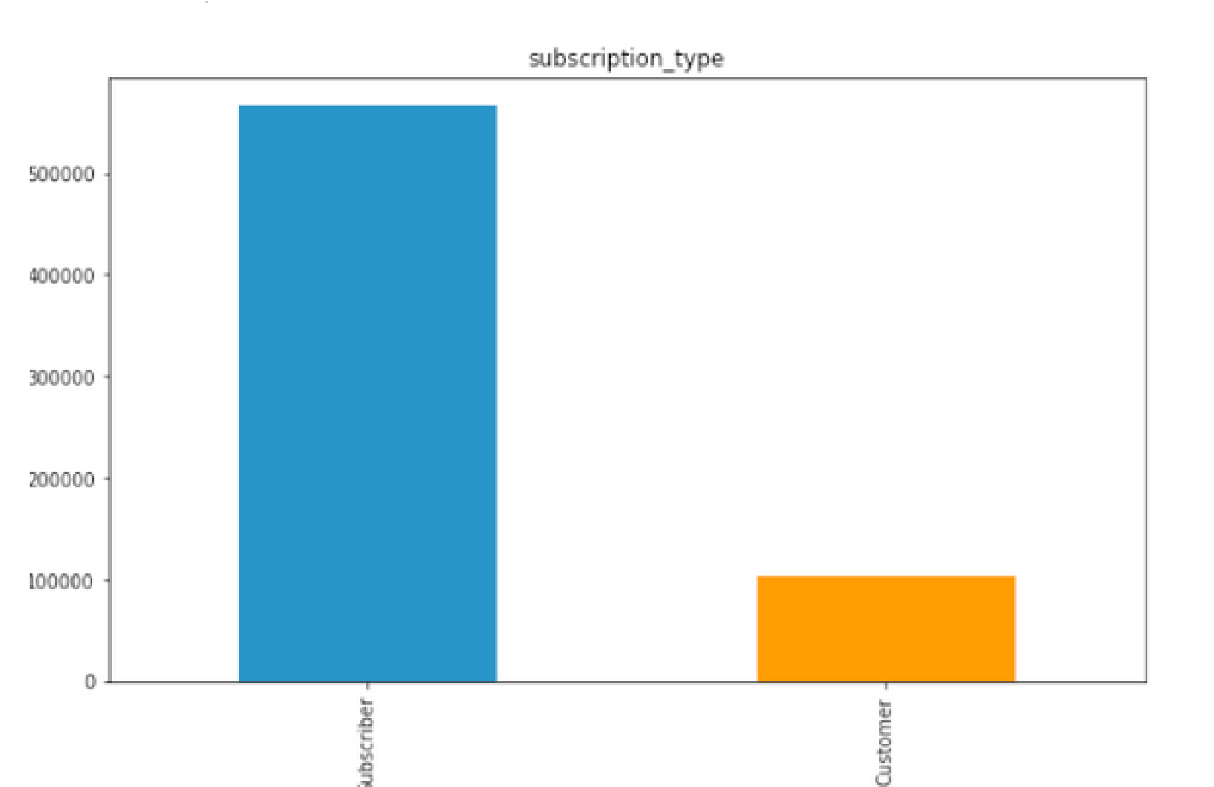

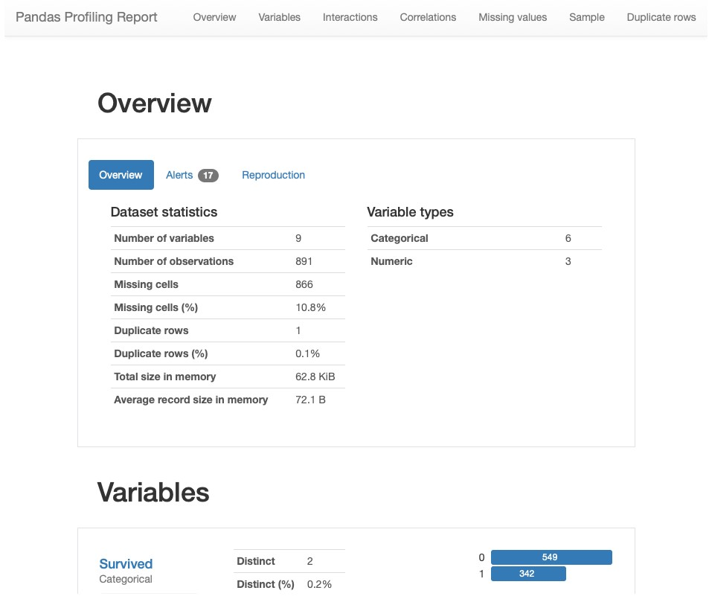• We also have automated data exploration/profiling

import pandas_profiling as pp df2.profile_report()

# Handing Missing Data Data can be Dirty

* Data in the real world is dirty
* **Incomplete**: lacking attribute values, lacking certain attributes of interest, or containing only aggregate data
* e.g., occupation=“”
* Comes from
* N/A data value when collected
* Different consideration between the time when the data was collected and when it is analyzed
* Human/hardware/software problems
* N/A may have a meaning
* **Noisy**: containing errors or outliers
* e.g., Salary=“-10”
* Comes from
* Collection
* Entry
* Transmission
* **Inconsistent**: containing discrepancies in codes or names
* e.g., Age=“42” Birthday=“03/07/1997”
* e.g., Was rating “1,2,3”, now rating “A, B, C”
* e.g., discrepancy between duplicate records
* Comes from
* Different data sources
* Functional dependency violation

# Missing Data

* Reasons for missing values
* Information is not collected
  1. g., people decline to give their age and weight)
* Attributes may not be applicable to all cases
  1. g., annual income is not applicable to children)
* E.g. many tuples have no recorded value for several attributes, such as customer income in sales data
* Missing data may be due to:
* Equipment malfunction
* Inconsistent with other recorded data and thus deleted
* Data not entered due to misunderstanding
* Certain data may not be considered important at the time of entry
* Not registering history or changes of the data
* Handling missing values
* Eliminate Data Objects
* Estimate Missing Values
* Ignore the Missing Value During Analysis
* Replace with all possible values (weighted by their probabilities)

# Missing Data

* Your data set could have missing data
* These will be missing values in the features/columns
* Algorithms don’t like missing values
* We need to fix these
* How
* If a Row/Record has a lot of missing values -> Delete it
* As it will be just filled with defaults (see below)
* If a Feature/Column has a lot of missing values -> Drop it, as it won’t contribute to any analysis
* Calculate (Impute) possible missing value -> Mean, Mode, Median
* Calculate (Impute) possible missing value -> Based on some calculation of one or more Features/Columns
* Replace with some default value

#Replace missing values with Zero #Does this for all Columns in dataframe df = df.fillna(0)

#Or for one Column

# replace 'DataFrame Column' with name of column df['DataFrame Column'] = df['DataFrame Column'].fillna(0)

#example - replace with default value df.country.fillna("Unknown")

#Check to see if a column contains nulls df[pd.isnull(df.country)]

#Alternatively, we may have a non-null value that we would like to replace df.taster_twitter_handle.replace("@kerinokeefe", "@kerino")

df **=** df**.**replace(['NO DATA','N/A', 0, ’’], np.nan) df **=** df**.**replace(['NO DATA','N/A', 0, ’’], ”Unknown")

The replace() method is worth mentioning here because it's handy for replacing missing data which is given some kind of sentinel value in the dataset: things like "Unknown", "Undisclosed", "Invalid", and so on.

Method 1: Fill NaN Values **in One Column** with Mean **df['col1'] = df['col1'].fillna(df['col1'].mean())**

Method 2: Fill NaN Values in **Multiple Columns** with Mean

**df[['col1', 'col2']] = df[['col1', 'col2']].fillna(df[['col1', 'col2']].mean())**

Method 3: Fill NaN Values in **All Columns** with Mean **df = df.fillna(df.mean())**

# Demo

Recoding Data (Transformations) Categorical & Numerical

## Cleaning Data

* Data set may include data objects that are duplicates, or almost duplicates of one another
* Major issue when merging data from heterogeous sources
* Can also be same data item entered in a different way
* Free format text
* Examples:
* Same person with multiple email addresses
* Data cleaning
* Process of dealing with duplicate data issues

Exercise – Get out a Pen and Paper / type up the following

Data Cleaning Problem

* Write the full work address for Brendan Tierney. (I’ll call it out and you can write it down)
* Type up what I’ve called out
* When you have finished -> Put it in the Chat window
* Share with class
* Do you get the same as everyone else?

37

Data Cleaning Problem

* Write the full work address for Brendan Tierney

|  |  |  |  |  |  |
| --- | --- | --- | --- | --- | --- |
| brendan tierney  school of computing science  technological university dublin  grangegorman dublin 7 ireland | | Brendan Tierney  School of Computing Science  Technological University Dublin  Grangegorman  Dublin 7  Ireland | | Brendan Tierney,  School of Computing Science,  Technological University Dublin,  Grangegorman,  Dublin 7, Ireland. | |
| Brendan Tierney,  School of Computing Science,  Technological University Dublin,  Grangegorman,  D7,  Ireland. | | Brendan Tierney,  School of Computing Science,  Technological University Dublin,  Grangegorman,  Dublin 7,  Ire. | |

There are lots and lots of other combinations. All of these are different.

38

## Converting Data

* Lots and Lots of possibilities here
* We will only cover some of these now
* Others will be covered in Data Wangling module
* Others we will covered throughout the semester in this module
* Generally – Data Analytics algorithms do not like attributes/features in Text format
* Convert to numerical
* Numerical Data -> Some formatting is needed

## Converting Text Data to Numerical Data

* Some examples include:
* A “*pet*” variable with the values: “*dog*” and “*cat*“.
* A “*color*” variable with the values: “*red*“, “*green*” and “*blue*“.
* A “*place*” variable with the values: “first”, “*second*” *and* “*third*“.

|  |
| --- |
| Let’s have a look at an example of each |

* Possible approaches
* One Hot Coding
* Find/Replace (Manual Coding)
* Label Encodings
* Everyone has the own favourite way of doing these things
* New approaches, libraries, code etc are coming available all the time
* The above are quick and easy for you to get started

### One-Hot Coding

* Creates a new attribute/feature for each distinct value
* If a categorical variable has 5 values, then 5 new attributes/features will be created

import pandas as pd import numpy as np import matplotlib as plt videoReview =

pd.read_csv('/Users/brendan.tierney/Downloads/Video_Games_Sales_as_at_22_Dec_2016.csv') videoReview.head(10)

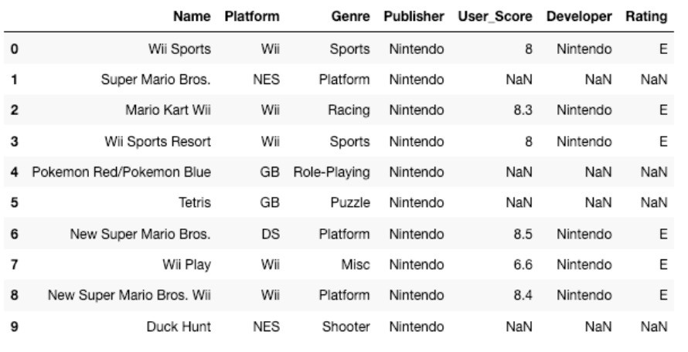

### One-Hot Coding

#apply one-hot-coding to all the categorical variables # and create a new dataframe to store the results

df2 = pd.get_dummies(df) df2.head(10)

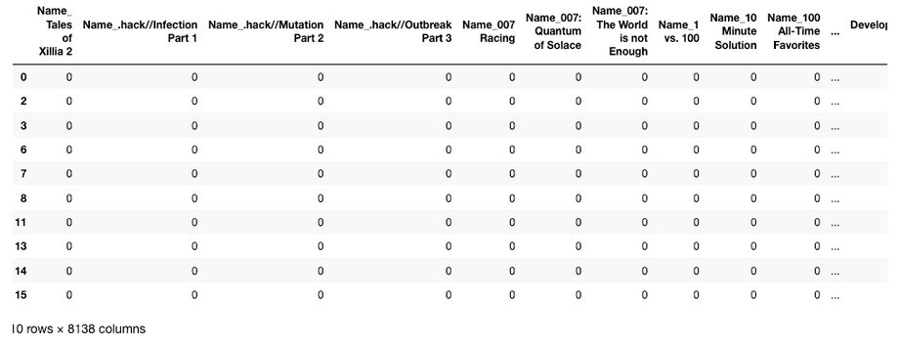

The original

data set had 7 attributes

/columns/features

Lots of additional attributes/features

Lots containing Zeros

Might not be suitable for data sets with

a large number of distinct categorical

attributes

Demo

### Find/Replace (Manual Coding)

* You can create a new attribute/feature and write code to do mapping to numeric

df['Rating'].value_counts() 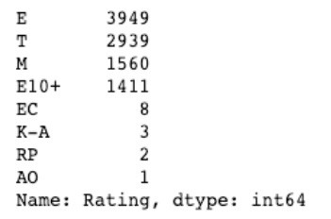

* The last 4 values listed have very small number of occurrences. • We will group these into having one value/category

find_replace = {"Rating" : {"E": 1, "T": 2, "M": 3, "E10+": 4, "EC": 5, "K-A": 5, "RP": 5, "AO": 5}} df.replace(find_replace, inplace=True) df.head(10)

Using same data set as previous example

### Find/Replace (Manual Coding)

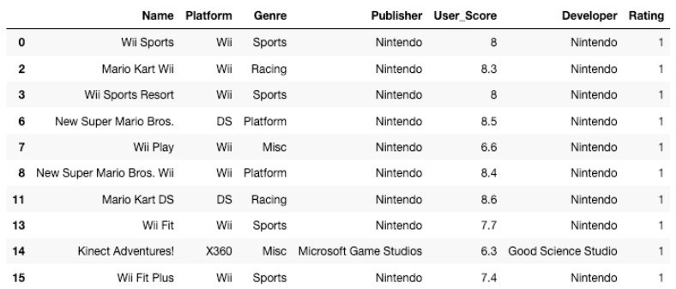

* You have greater control over what is created
* Fewer attributes/features needed
* More understanding of the data needed, and on how data can be grouped
* More coding needed Demo

### Label Encodings

* With this technique where each distinct value in a categorical variable is converted to a number.
* In this scenario you don’t get to pick the numeric value assigned to the value. It is system determined.
* Our categorical variables are of ‘object’ data type. We need to convert to a category data type.
* In this example ‘Platform’ has a large-ish number of values and we want a quick way of converting them we can illustrate this by creating a new variable.

df["Platform_Category"] = df["Platform"].astype('category') df.dtypes

* Now convert this new variable to numeric.

df["Platform_Category"] = df["Platform_Category"].cat.codes df.head(20)

|  |  |
| --- | --- |
|  | • The number assigned to the Platform_Category variable is based on the alphabetical ordering |
|  | of the values in the Platform variable. For example, |

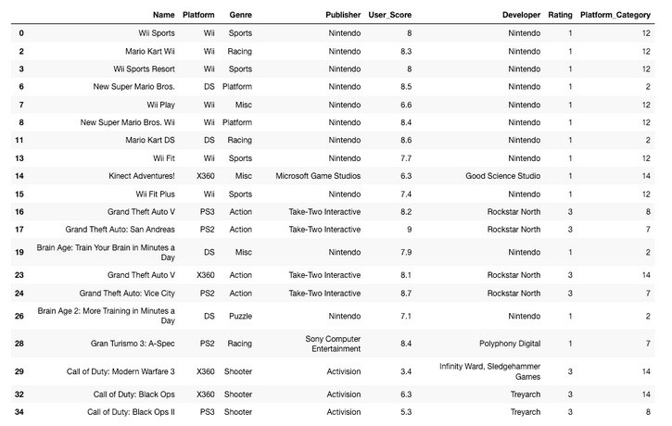 df.groupby("Platform")["Platform"].count()

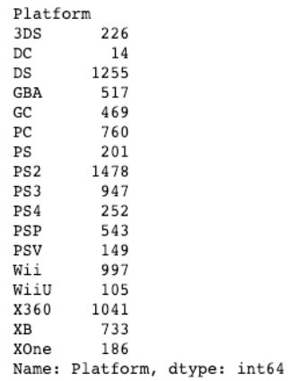

Demo

### Label Encodings – Using SciKit-Learn

* SciKit-Learn has a number of functions to help with data encodings. The first one we will look at is the ‘fit_transform’ function.
* This will perform a similar task to what we have seen in a previous example

#Let's use the fit_tranforms function to encode the Genre variable from sklearn.preprocessing import LabelEncoder

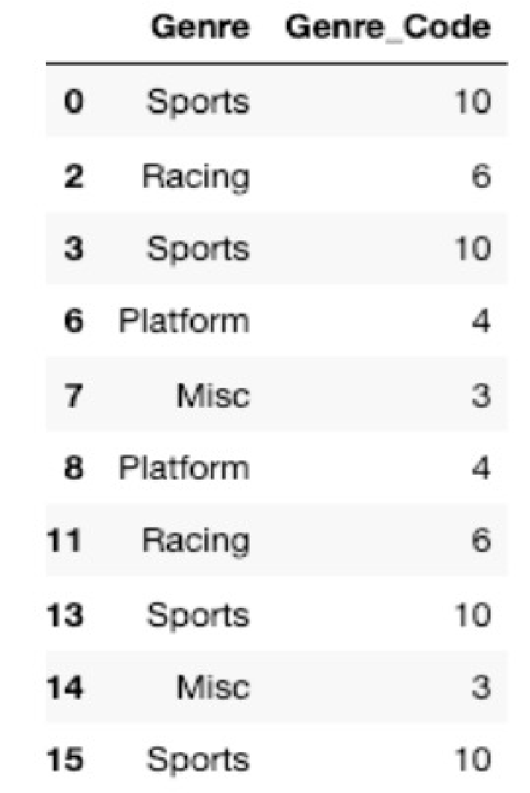

Demo

le_make = LabelEncoder() df["Genre_Code"] = le_make.fit_transform(df["Genre"]) df[["Genre", "Genre_Code"]].head(10)

What about Numerical Data?

* Normalization is a technique often applied as part of data preparation for machine learning.
* The goal of normalization is to change the values of numeric columns in the dataset to use a common scale, without distorting differences in the ranges of values or losing information.
* For example, assume your input dataset contains one column with values ranging from 0 to 1, and another column with values ranging from 10,000 to 100,000. The great difference in the *scale* of the numbers could cause problems when you attempt to combine the values as features during modeling
* There are several approaches to this (experimentation needed to determine), common ones are:
* Min-Max Scaling: Subtract the min value from each column’s highest value and divide by the range.
* Standardization Scaling: Subtracting the mean of each observation and dividing by the standard deviation

### What about Numerical Data

* Example Data
* Salaries
* Temperatures
* Prices
* Salaries
* Sales
* Populations
* All have ranges from Zero to some large number
* Convert to common scale to allow the algorithms to compare
* Otherwise the attributes/features with larger numbers will have a greater influence to those attributes with small variables
* The algorithms may use these attributes incorrectly, and the models produced may not be the best

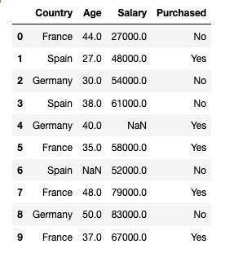

import pandas as pd

import

numpy

as np

import seaborn as

sns

import

matplotlib.pyplot

as

plt

from

sklearn.preprocessing

import

MinMaxScaler

data.head

(10)

# <

--

See results to the left

scaler =

MinMaxScaler

()

data[['Age', 'Salary']] =

scaler.fit_transform

(

data[['Age', 'Salary'

]])

data



import pandas as pd

import

numpy

as np

import seaborn as

sns

import

matplotlib.pyplot

as

plt

from

sklearn.preprocessing

import

MinMaxScaler

data.head

(10)

# <

--

See results to the left

scaler =

MinMaxScaler

()

data[['Age', 'Salary']] =

scaler.fit_transform

(

data[['Age', 'Salary'

]])

data

#

See

results to the right

--

>

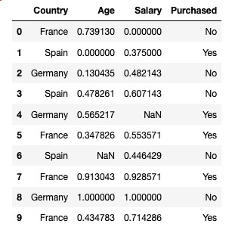

Demo

### Lots of functions available

* 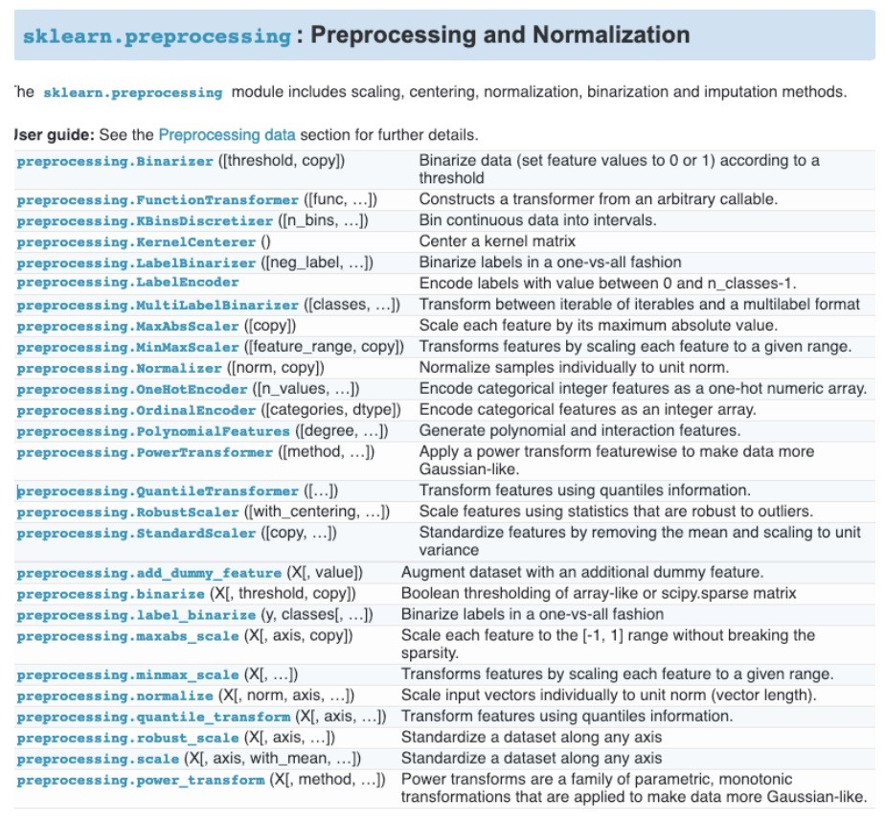Lots of options
* Remember to Keep It Simple
* Start Simple and with the basics
* As your knowledge and experience grows, explore some of the others

### Correlated Data

* Correlation explains how one or more variables are related to each other.
* If two variables are closely correlated, then we can predict one variable from the other
* Examples
* Income and Expenditure of an individual
* Demand and price of a commodity
* Age and Insurance Claims
* Why is this important?
* Can help clean up the data set
* Reduce/Remove variables that are highly correlated
* As they indicate the same thing, meaning, outcome, etc

|  |  |  |  |
| --- | --- | --- | --- |
| Name | Model Role | Measurement Level | Description |
| CUSTID | ID | Nominal | Customer loyalty identification number |
| GENDER | Input | Nominal | M = male, F = female, U = unknown |
| DOB | Input | Interval | Date of birth |
| EDATE | Input | Unary | Date extracted from the daily sales data base |
| AGE | Input | Interval | Age, in years |
| AGEGRP1 | Input | Nominal | Age group 1 |
| AGEGRP2 | Input | Nominal | Age group 2 |
| TV_REG | Input | Nominal | Television region |
| NGROUP | Input | Nominal | Neighborhood group |
| NEIGHBORHOOD | Input | Nominal | Type of residential neighborhood |
| LCDATE | Input | Interval | Loyalty card application date |
| LTIME | Input | Interval | Time as loyalty card member |
| ORGANICS | Input | Interval | Number of organic products purchased |
| BILL | Input | Interval | Total amount spent |
| REGION | Input | Nominal | Geographic region |
| CLASS | Input | Nominal | Customer loyalty status: tin, silver, gold, or platinum |
| ORGYN | Input | Binary | Organics purchased? 1 = Yes, 0 = No |
| AFFL | Input | Interval | Affluence grade on a scale from 1 to 30 |

* A supermarket is beginning to offer a new line of organic products. The supermarket’s management would like to determine which customers are likely to purchase these products.
* The supermarket has a customer loyalty program. As an initial buyer incentive plan, the supermarket provided coupons for the organic products to all of their loyalty program participants and has now collected data that includes whether or not these customers have purchased any of the organic products.

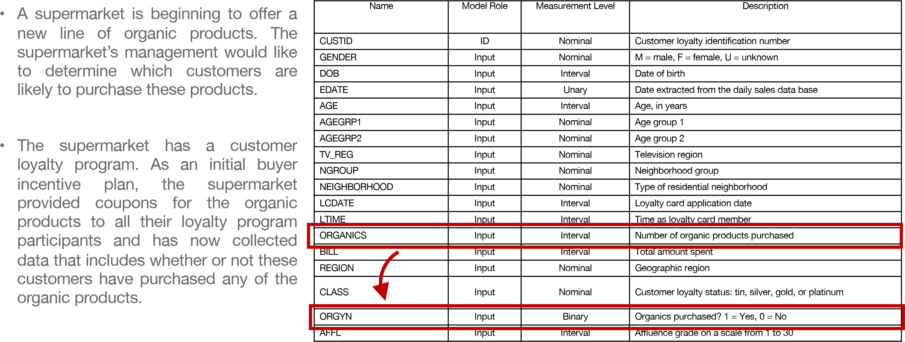

ORGANICS and ORGYN are highly correlated

import pandas as pd

#read in the data set

data =

pd.read_csv

(

'/Users/

brendan.tierney

/Dropbox/4

-

Datasets/

boston

-

housing

-

dataset.csv

’)

corr_matrix

=

data.corr

()

corr_matrix

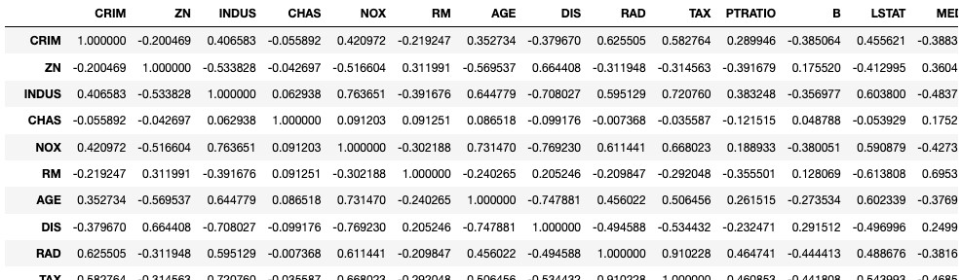

import pandas as pd

#read in the data set

data =

pd.read_csv

(

'/Users/

brendan.tierney

/Dropbox/4

-

Datasets/

boston

-

housing

-

dataset.csv

’)

corr_matrix

=

data.corr

()

corr_matrix

import seaborn as

sn

fig =

plt.subplots

(

figsize

=(17,14))

sn.heatmap

(

corr_matrix

,

annot

=

True

)

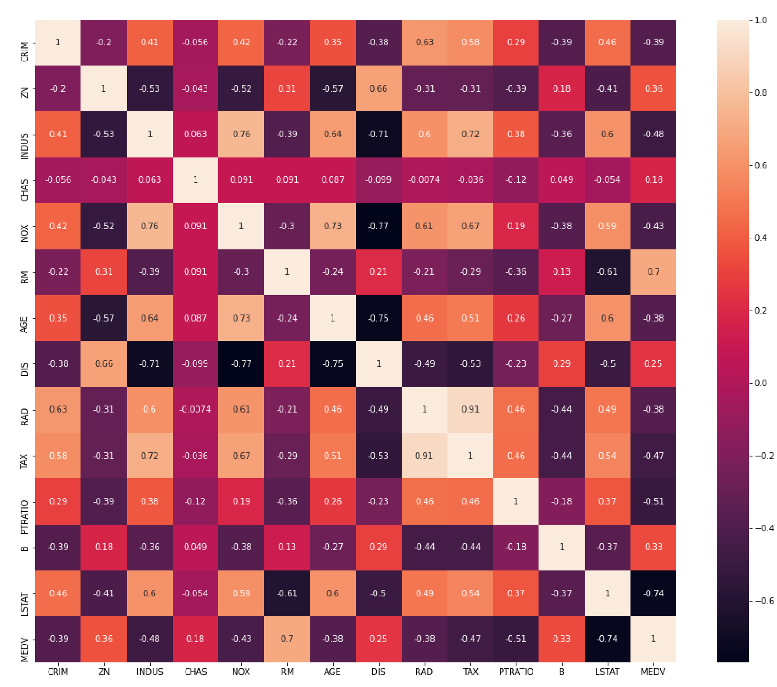

"tax" and "rad" columns are highly correlated with value of 0.91(positive correlation).

Some of the features are negatively correlated and their

correlation

value is negatively

high. Such as "

lstat

" vs "

medv

", "dis" vs "

indus

", "dis" vs "age".

From the above observations, we can conclude that there is

a hidden

covariation

between the tax rate and the index of accessibility to radial highways.

We can derive a relationship that if the house accessibility to highways is high then the

full

-

value property

-

tax rate will also be higher.

This may sound like a genuine thing, because of the houses with high price generally

nearer to market, good amenities, highways, etc.

Demo

### Splitting Data, Sampling and Final Steps

Are we nearly there?

* Yes we are :-)
* The finals steps are really dependent on what you will do next
* 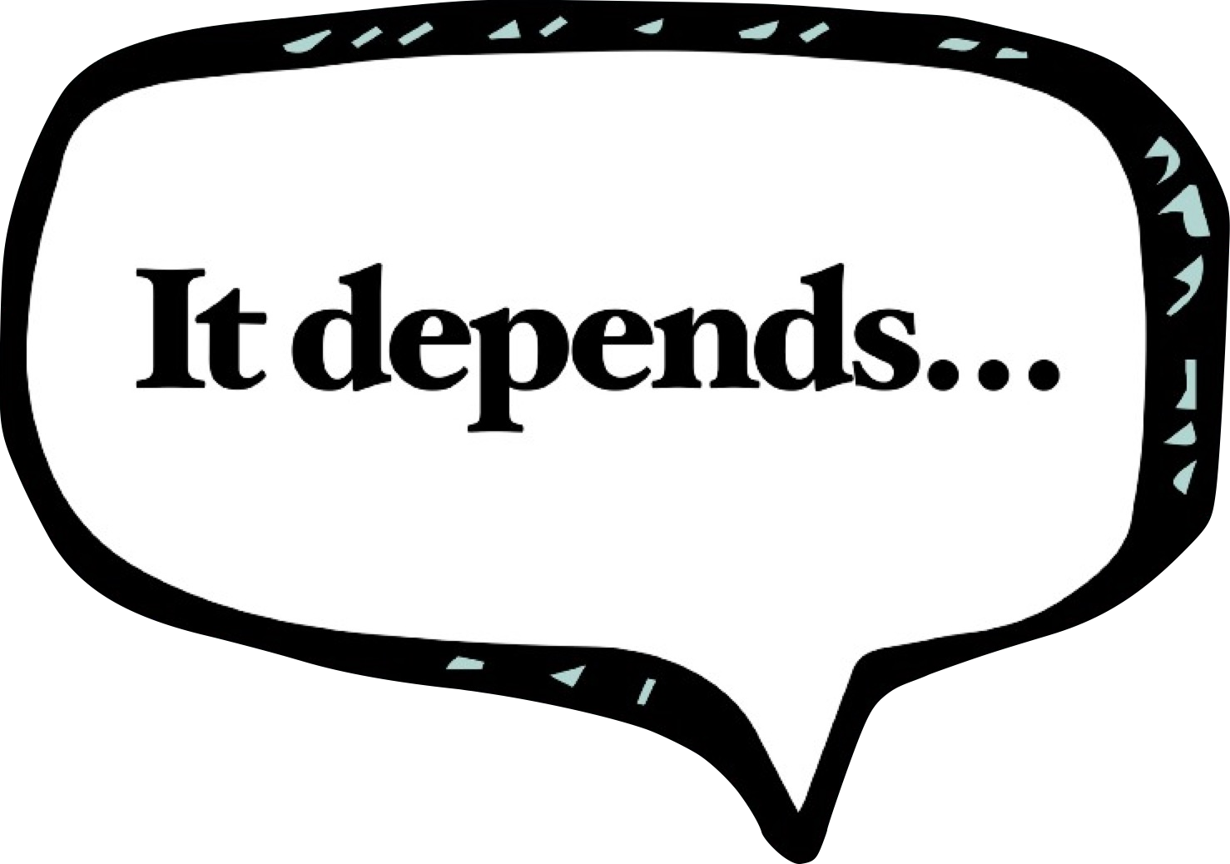What visualisations
* What Tools
* What Languages
* What Algorithms
* What APIs, web services, functions

### For Supervised Machine Learning

* e.g. Classification, Regression
* Training Data set
* Used to create the ML Model
* Representative of entire data
* Testing Data set
* Use for testing the ML Model
* How good is it at making predictions
* How many predictions are correct
* 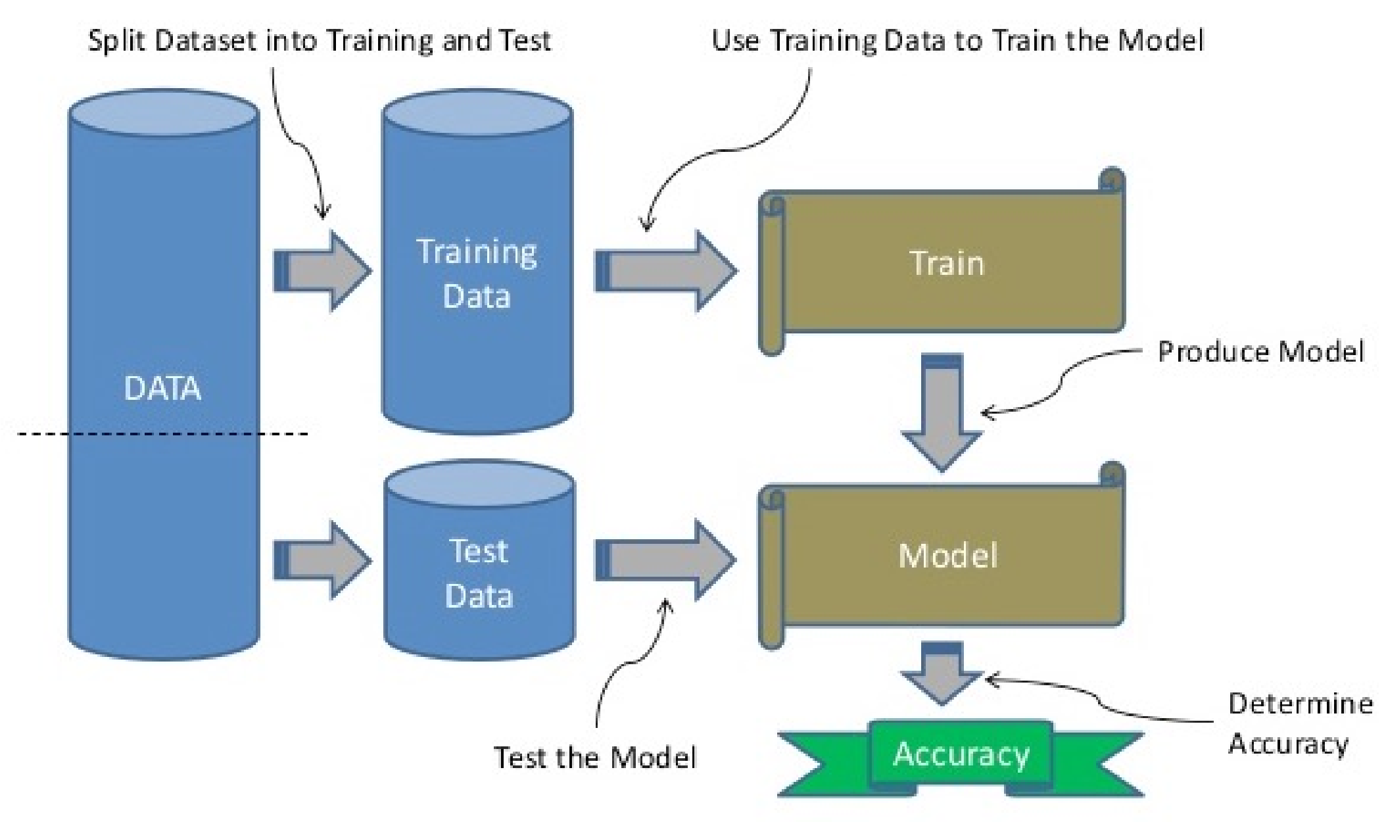How many predictions it got wrong
* 70-30 split
* 60-40 split

### Example – train_test_split

* Will split the data set into 2 different dataframes
* Needs to have one of test_size or train_size defined, in range 0 to 1.0 from sklearn.model_selection import train_test_split training_data, testing_data = train_test_split(df, test_size=0.2, random_state=25)
* 2 Data Sets are created
* Test Data Set will contain 20% of records, as defined by parameter
* Training Data Set will contain 80% of records, calculated by default from test_size parameter
* Limitation might result in Training and Test not having representative numbers of each Target value

### Example – Using proportional sampling

* Stratified Sampling
* 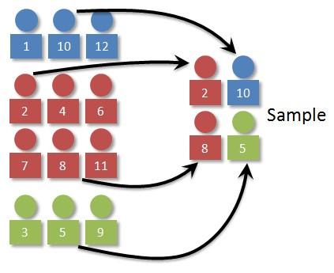Divide the population into subgroups or into strata, and instances are sampled from each stratum to guarantee that the test set is representative of the entire population.
* Stratified sampling is different from simple random sampling, which involves the random selection of data from the entire population so that each possible sample is equally likely to occur.
* A random sample is taken from each stratum in direct proportion to the size of the stratum compared to the population, so each possible sample is equally likely to occur.

from sklearn.model_selection import train_test_split training_data, testing_data = train_test_split(df, test_size=0.2, random_state=25, **stratify=y**)

### Example – Using proportional sampling

#After the data is prepared, we can now divide the data into the Training and Test data sets.

import random random.seed(3434200)

# use Stratified sampling to divide the data

from sklearn.model_selection import **StratifiedShuffleSplit** split = **StratifiedShuffleSplit**(n_splits=10, test_size = 0.2, random_state=18)

for train_index, test_index in split.split(df_new, df_new['y']):

train_set = df_new.loc[train_index] test_set = df_new.loc[test_index]

#### Stratified Sampling ensure proportional representation in each sub-group

**#**

**Calculate the distributions for each of the Target variables. We have an imbalanced data set**

**.**

df

[

'y'

].

value_counts

()

# dataset is imbalanced with majority of class label as "no".

no

36548

yes

4640

df

[

'y'

].

value_counts

()

/

len

(

df

)

#calculate percentages

no

0.887346

yes

0.112654

**#**

**Check the sizes of the Training and Test data sets.**

train_set

[

'y'

].

value_counts

()

0

29238

1

3712

train_set

[

'y'

].

value_counts

()

/

len

(

train_set

)

0

0.887344

1

0.112656

**#Check the Test data set**

test_set

[

'y'

].

value_counts

()

0

7310

1

928

test_set

[

'y'

].

value_counts

()

/

len

(

test_set

)

0

0.887351

1

0.112649

Stratified Sampling ensure proportional representation in each sub

-

group

### For Un-Supervised Machine Learning

* e.g. Clustering, Association Rules Analysis, Text Mining, Forecasting, etc
* Nothing more to do
* All done
* Just pass the data set (dataframe) into the algorithms

### Imbalanced Data Sets For Classification & Regression Algorithms

* For Classification & Regression Algorithms
* They look to learn how the attributes and their values contribute towards the Target attribute
* Need to have enough examples or records of each value of Target attribute
* Split the available data into a *training set* and a *test set*

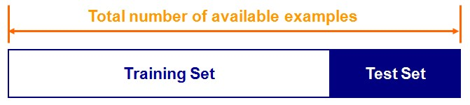

* Train the classifier in the training set and evaluate based on the test set
* A couple of drawbacks
* We may not have enough data
* We may happen upon an *unfortunate split*

### Imbalanced Data Sets

* One Target value has more than the other
* Not a problem if difference is small
* If we use the data => a biased model
* It will be good at predicting one of the Target values
* And rubbish at predicting the other value

|  |  |
| --- | --- |
| < 10% | > 90% |

Customer Churn

Data Set

#### Imbalanced Data Sets

•

Typically, One Target value has more than the other

•

Very common in real world

•

Typically want to predict the smaller “thing”

•

Not a problem if differences in Target attribute (in number of

records) is small

•

If we use the Imbalanced data set => a biased model

•

It will be good at predicting one of the Target values (

most

number of records)

•

And

rubbish

at predicting the other value (lower number of

records

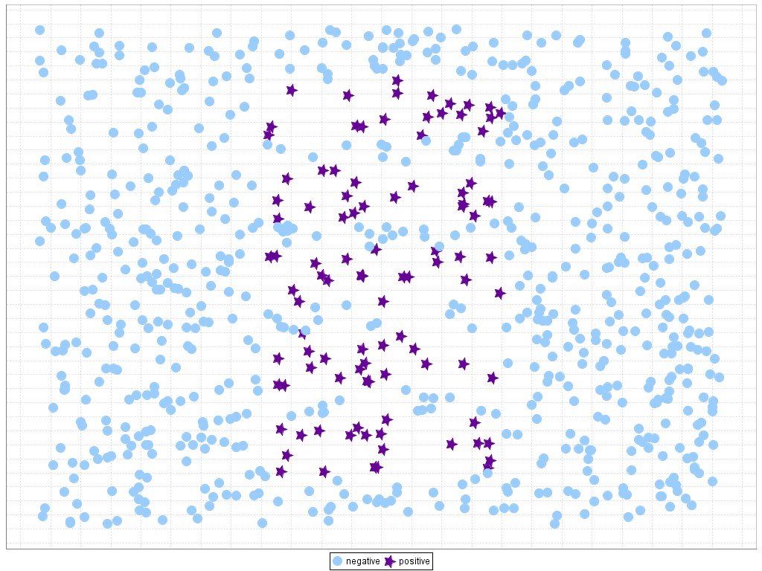

|  |  |
| --- | --- |
| < 10% | > 90% |

Customer Churn Data Set

#### How to manage Imbalanced Data Sets

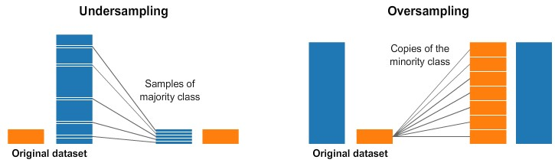

* Under Sample
* Remove records from data set
* Random (but how random is it really)
* How can you ensure representative samples remain.
* May end up removing important cases

Issues with reducing the size of data set

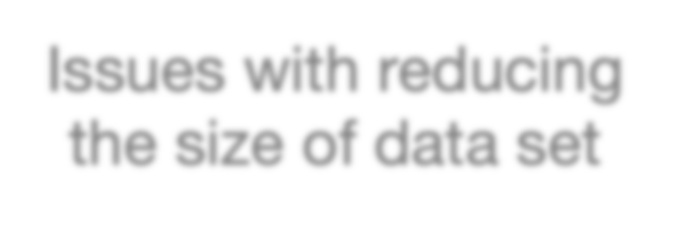

#### How to manage Imbalanced Data Sets



* Over Sample
* Repeat/Duplicate records - Quick and Easy, by has Limitations (biases, no-variances, etc)
* SMOTE: Synthetic Minority Over-sampling Technique
* take a sample from the dataset, and consider its *k* nearest neighbors (in feature space). To create a synthetic data point, take the vector between one of those *k* neighbors, and the current data point. Multiply this vector by a random number *x* which lies between 0, and 1. Add this to the current data point to create the new, synthetic data point. Allows for possible data variations, within current ranges.

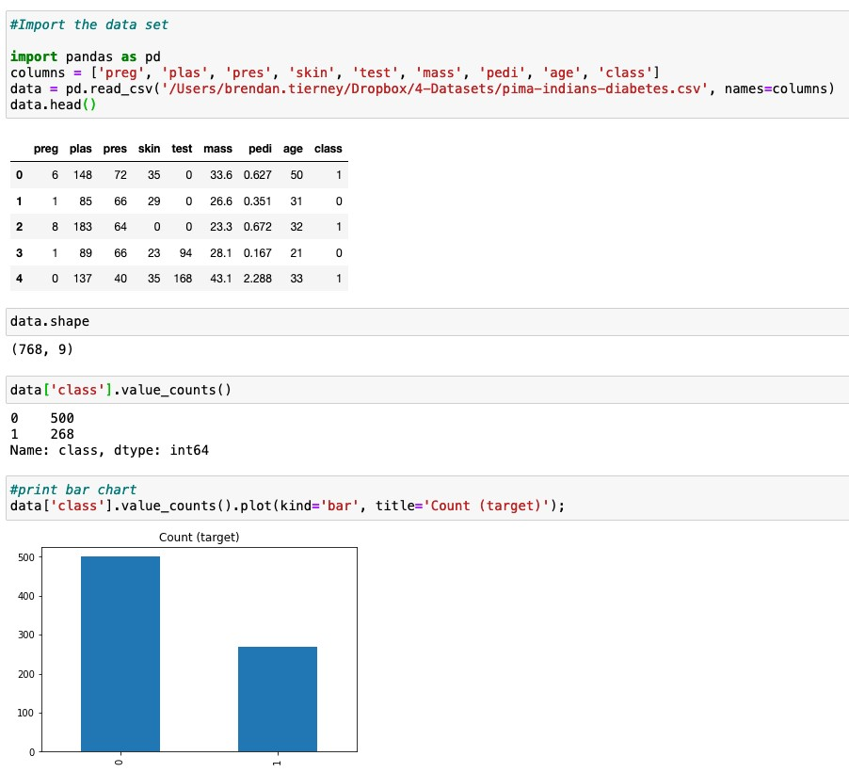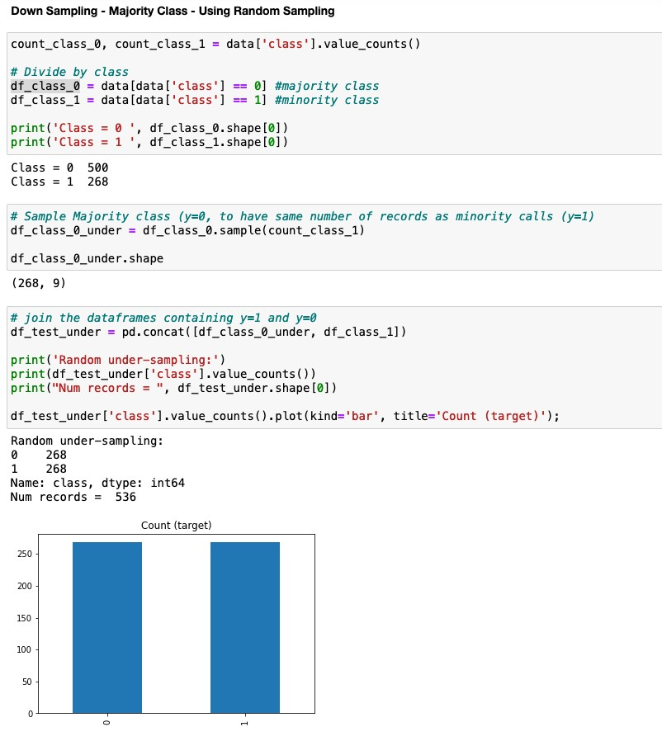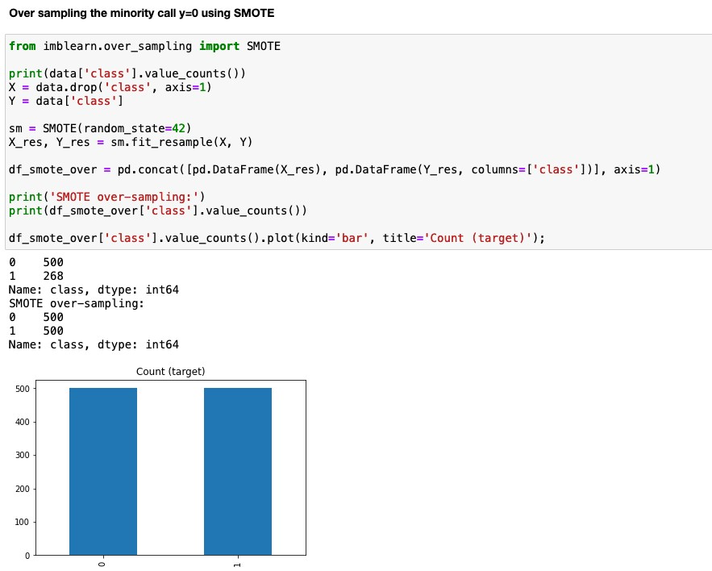

Demo

#### Iterative in Nature



79

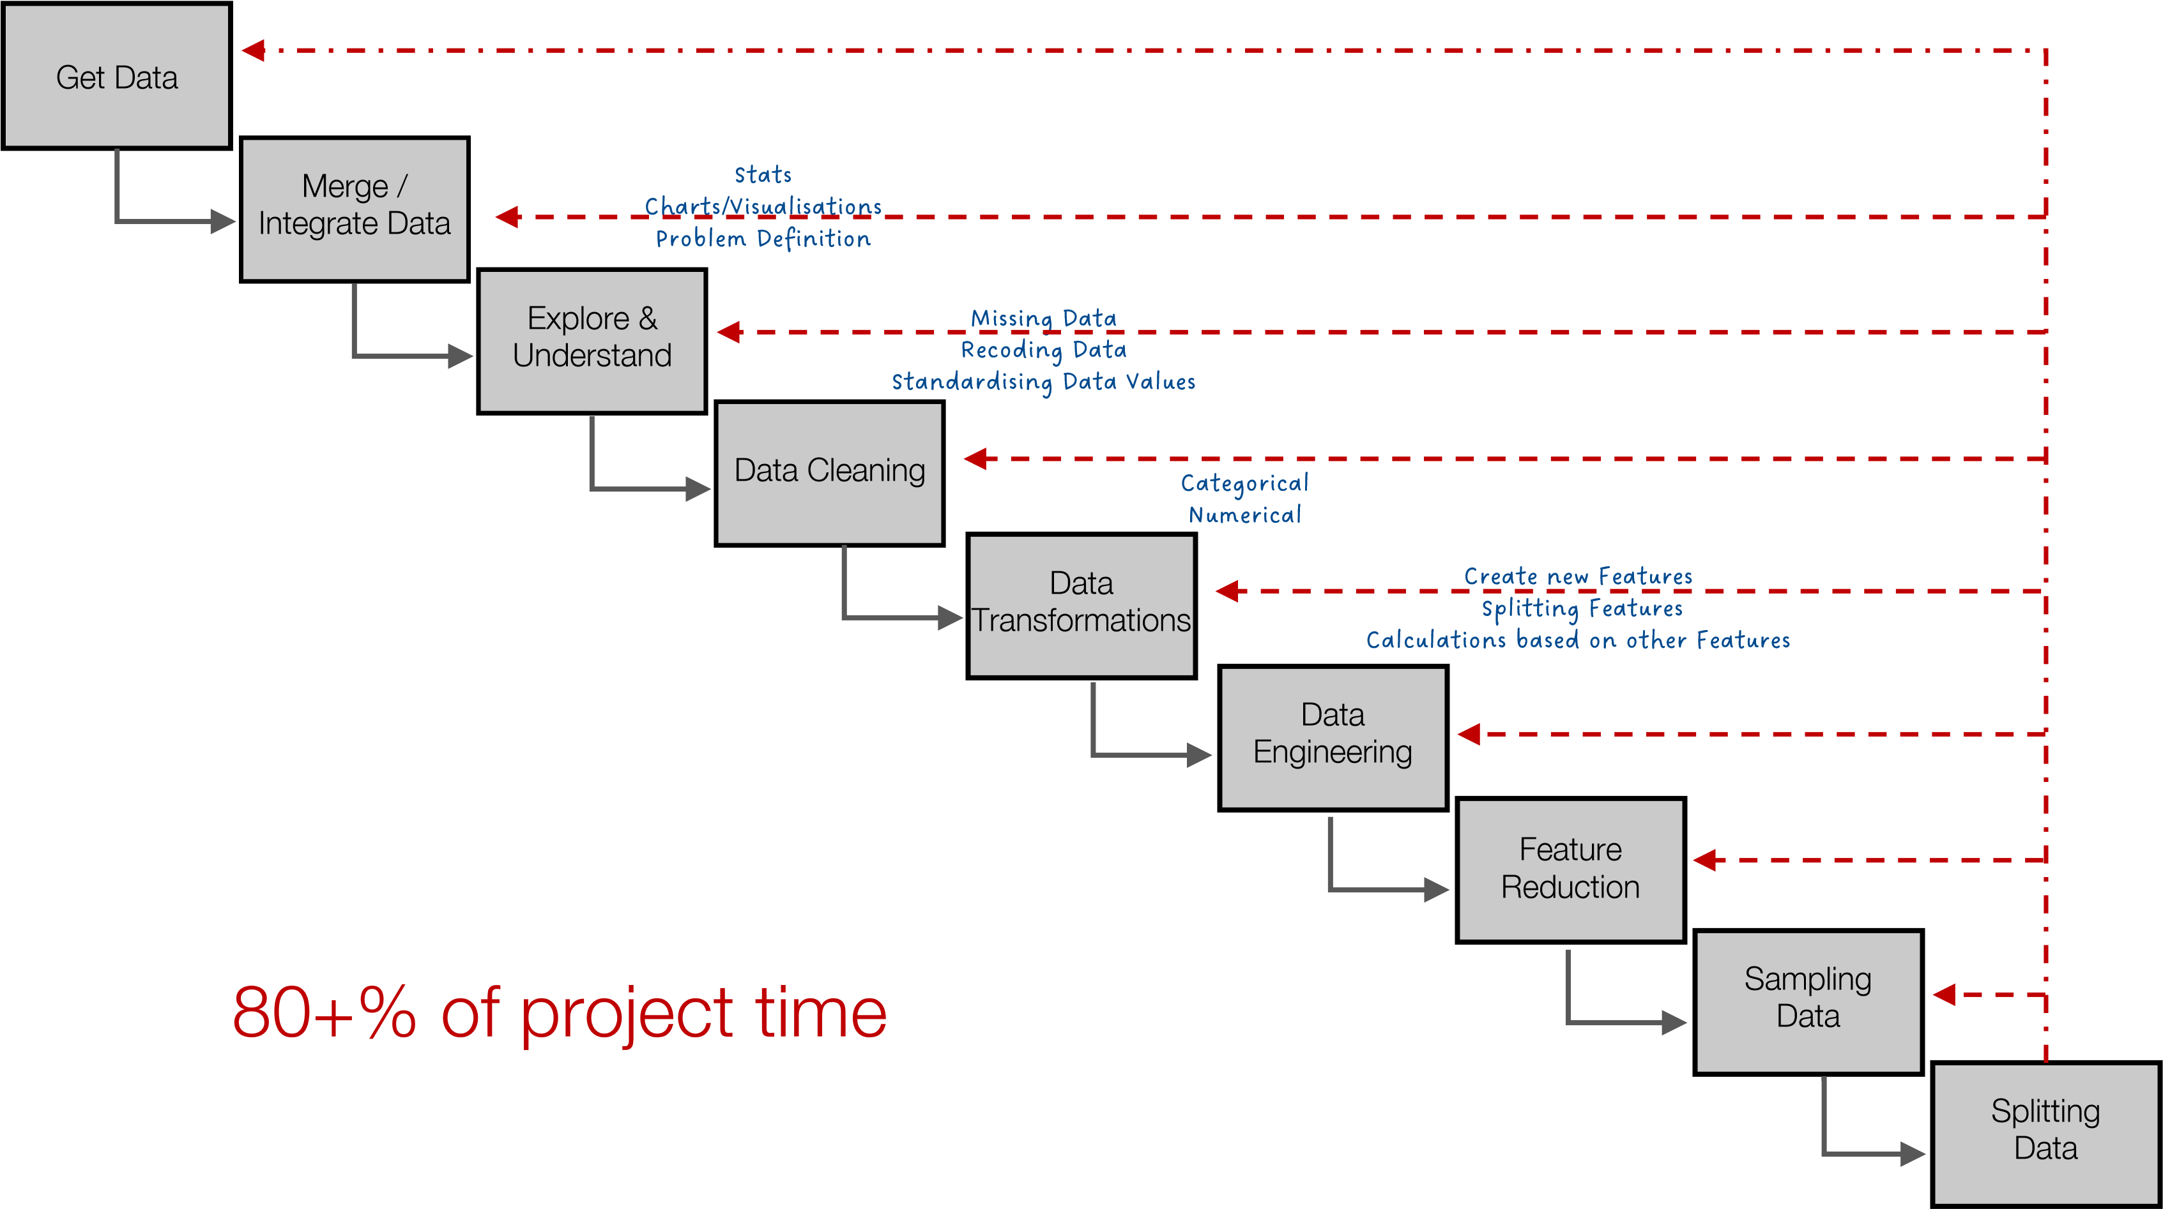

#### Your Toolbox



•

Lots of possible tasks to do

•

Sometimes it can be a little confusing what you need to do

•

Keep it Simple. Iterate. Built upon. Learn

•

Start simple and learn/experiment

•

We haven’t covered all possibilities

•

But we have covered more than enough to get started

•

Build and Learn from each example



Any Questions ?

What Now/Next ?



Data Leakage

•

Data leakage is when information from outside the training

dataset is used to create the model.

•

Your Data Set

contains features

which were

created after

the

Event

your data set represents.

•

Your Data Set contains records that represent an Event.

•

Details of Customer leading up to them Buying a Product

•

Customer details leading up to them being involved in a Marketing

Campaign

•

Examples

•

How long did it take for the Customer to Buy their next product

•

Did the customer Buy the product

•

How long were they on the Call

•

the longer the call the more likely (correlated) to buying the

product

•

The shorter the call means they didn’t buy



* Data Leakage can be applied to many different types of problems

•

For Data Science/Mining etc it refers to

data quality issue

•

It can affect the Analysis, Data Understanding, Visualisations,

Models, Interoperation of results, etc

•

(

Target) Data Leakage happens if you train your model on

information that would

NOT

be available at the point in time when

you

use

the model

in production

to score newly collected data

85

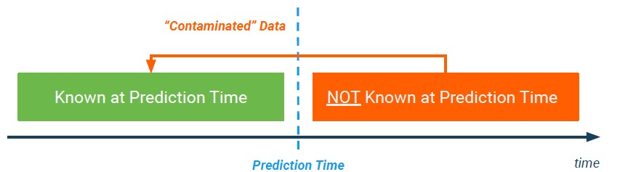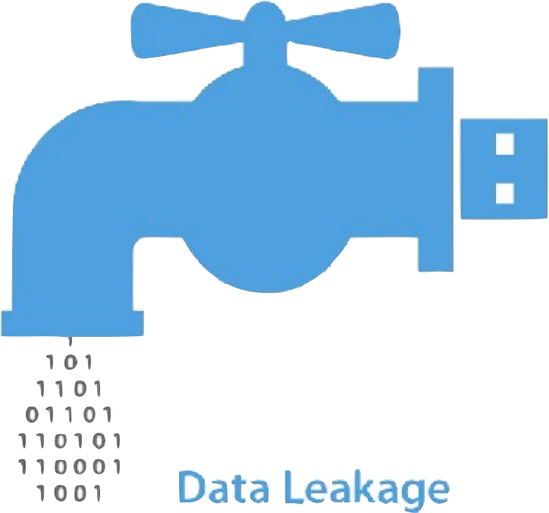

* Less common if you are building the data set yourself
* Can be very common in publicly available Data Sets.
* Always check the Meta-Data / Data Dictionary.
* And any other information provided for the Data Set.
* Remove these features from the Data Set.
* These features Might appear as Strong indicators in Machine Learning models.
* For example, imagine you want to predict who will get sick with pneumonia.

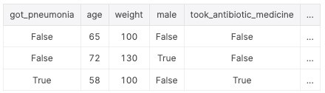

87

#### Data Leakage - Example

• Bank Marketing Data Set [- https://archive.ics.uci.edu/ml/datasets/bank+marketin](https://archive.ics.uci.edu/ml/datasets/bank+marketing)g

1. - age (numeric)
2. - job : t ype of job (categorical: 'admin.','blue-collar','entrepreneur','housemaid','management','retired','self-employed’, 'services’, 'student’, 'technician’, 'unemployed’, 'unknown')
3. - marital : marital status (categorical: 'divorced','married','single','unknown'; note: 'divorced' means divorced or widowed)
4. - education (categorical: 'basic.4y','basic.6y','basic.9y','high.school','illiterate','professional.course','university.degree','unknown') 5 - default: has credit in default? (categorical: 'no','yes','unknown')

6 - housing: has housing loan? (categorical: 'no','yes','unknown') 7 - loan: has personal loan? (categorical: 'no','yes','unknown') # related with the last contact of the current campaign:

1. - contact: contact communication type (categorical: 'cellular','telephone')
2. - month: last contact month of year (categorical: 'jan', 'feb', 'mar', ..., 'nov', 'dec') 10 - day_of_week: last contact day of the week (categorical: 'mon','tue','wed','thu','fri')
3. - duration: last contact duration, in seconds (numeric). # other attributes:
4. - campaign: number of contacts performed during this campaign and for this client (numeric, includes last contact)
5. - pdays: number of days that passed by after the client was last contacted from a previous campaign (numeric; 999 means client was not previously contacted) 14 - previous: number of contacts performed before this campaign and for this client (numeric)

|  |
| --- |
| Do we have an example of Data Leakage in this Data Set?  Example the information and come up with a possible features |

1. - poutcome: outcome of the previous marketing campaign (categorical: 'failure','nonexistent','success') # social and economic context attributes
2. - emp.var.rate: employment variation rate - quarterly indicator (numeric)
3. - cons.price.idx: consumer price index - monthly indicator (numeric)
4. - cons.conf.idx: consumer confidence index - monthly indicator (numeric)
5. - euribor3m: euribor 3 month rate - daily indicator (numeric) 20 - nr.employed: number of employees - quarterly indicator (numeric)

Output variable (desired target):

21 - y - has the client subscribed a term deposit? (binary: 'yes','no')

#### Data Leakage - Example

• Bank Marketing Data Set [- https://archive.ics.uci.edu/ml/datasets/bank+marketin](https://archive.ics.uci.edu/ml/datasets/bank+marketing)g

1. - age (numeric)
2. - job : t ype of job (categorical: 'admin.','blue-collar','entrepreneur','housemaid','management','retired','self-employed’, 'services’, 'student’, 'technician’, 'unemployed’, 'unknown')
3. - marital : marital status (categorical: 'divorced','married','single','unknown'; note: 'divorced' means divorced or widowed)
4. - education (categorical: 'basic.4y','basic.6y','basic.9y','high.school','illiterate','professional.course','university.degree','unknown') 5 - default: has credit in default? (categorical: 'no','yes','unknown')

6 - housing: has housing loan? (categorical: 'no','yes','unknown') 7 - loan: has personal loan? (categorical: 'no','yes','unknown') # related with the last contact of the current campaign:

1. - contact: contact communication type (categorical: 'cellular','telephone')
2. - month: last contact month of year (categorical: 'jan', 'feb', 'mar', ..., 'nov', 'dec')
3. - day_of_week: last contact day of the week (categorical: 'mon','tue','wed','thu','fri')
4. - duration: last contact duration, in seconds (numeric). Important note: this attribute highly affects the output target (e.g., if duration=0 then y='no'). Yet, the duration is not known before a call is performed. Also, after the end of the call y is obviously known. Thus, this input should only be included for benchmark purposes and should be discarded if the intention is to have a realistic predictive model.

# other attributes:

1. - campaign: number of contacts performed during this campaign and for this client (numeric, includes last contact)
2. - pdays: number of days that passed by after the client was last contacted from a previous campaign (numeric; 999 means client was not previously contacted) 14 - previous: number of contacts performed before this campaign and for this client (numeric)
3. - poutcome: outcome of the previous marketing campaign (categorical: 'failure','nonexistent','success') # social and economic context attributes
4. - emp.var.rate: employment variation rate - quarterly indicator (numeric)
5. - cons.price.idx: consumer price index - monthly indicator (numeric)
6. - cons.conf.idx: consumer confidence index - monthly indicator (numeric)
7. - euribor3m: euribor 3 month rate - daily indicator (numeric) 20 - nr.employed: number of employees - quarterly indicator (numeric)

Output variable (desired target):

21 - y - has the client subscribed a term deposit? (binary: 'yes','no')

df = df.drop('duration', axis=1)

#### Your Toolbox

* Lots of possible tasks to do
* Sometimes it can be a little confusing what you need to do
* Keep it Simple. Iterate. Built upon. Learn
* Start simple and learn/experiment
* We haven’t covered all possibilities
* But we have covered more than enough to get started
* Build and Learn from each example

Any Questions ?

What Now/Next ?